Job Description

Job Title: Programme Manager (Technical Lead)

Group: International

Dept/Project/Service: MCF Leaders in Teaching (LiT)

Reports to: Director SSA, Dotted line to LiT Consortium Lead (Consortium Lead Partner)

Responsible for: Regional Education Leads, MEAL Manager, Programme Coordinator, Gender, Safeguarding and Inclusion Specialist, Finance Manager, HR and Admin Manager, Communications and Advocacy Officer

Usual office base: Addis Ababa

Grade: Will be awarded following job evaluation

Project Overview:
The Leaders in Training (LiT) Ethiopia is a national programme aiming to enhance quality of teaching and learning in secondary education. The overall objective of the programme is to improve the transition of secondary school students to either post-secondary education or training or directly into the world of work by equipping them with relevant skills, knowledge, and attitudes through enhanced implementation of the competency-based curriculum. EDT are implementing this programme in partnership with two other organisations, one of whom, the Lead Partner, will also host the Project Management Unit (PMU).

Job Purpose and Scope:
The Programme Manager (Technical Lead) is responsible for the overall coordination and technical leadership of EDT’s implementation of the LiT project. This role involves developing operational plans and budgets, liaising with external stakeholders and consortium partners, and ensuring the programme team delivers all agreed outputs to the required quality and resources. They will also have an oversight role into the design of the teacher professional development and school leader training, and will oversee the delivery. The Programme Manager (Technical Lead) will also collaborate with the SSA Regional Team to support internal monitoring and reporting procedures, providing updates and reports, and implementing delivery excellence as prescribed in the SSA delivery excellence framework.
This Job Description may be amended when the Programme is finalised
Job objectives:
- Provide overall strategic leadership and management of the programme, ensuring the project team delivers all agreed outputs and milestones on time and to agreed quality standards.

- Oversee the efficient management of the operations and administration aspects of the programme as agreed between Education Development Trust, Mastercard, Ministry of Education (MoE), and other key stakeholders.

- Represent EDT in defining the programme’s governance arrangements and ensuring that such arrangements are understood and adhered to.

- Implement and embed SSA delivery excellence processes, tools, and standards in collaboration with the Director-SSA.

- Oversee the work of the Senior Regional Education Lead, PMU technical expert and EDT technical experts to ensure that course content for school leaders and teacher development is high quality and is in line with Ministry of Education policies

- Oversee regional activities to ensure that pre and in-service training provided to teachers and school leaders is high quality, evaluated and continuously improved.

- Prepare and maintain up-to-date costed project and activity plans across all workstreams, in consultation with the Director SSA. Ensure compliance with client and corporate requirements, and adherence to contract terms, KPIs, and deliverables

- Monitor the progress of the project, managing issues, risks, actions, and decisions, and escalating to the EDT Director SSA and PMU Consortium Lead as necessary.

- Ensure change management and adaptive programming methodologies are embedded in the programme’s processes.

- Provide oversight of project outcomes and budgets, working with the MEAL and finance teams to ensure overall success of the project.

- Establish strong relationships with various stakeholders, including government, consortium partners, and Education Development Trust’s Regional team.

- Facilitate proactive client engagement, organising client meetings, and following up on agreed actions.

- Oversee the project dashboard report and update the PMU on progress against targets, budgets, and associated risks.

- Ensure the safety of staff and partners in line with duty of care and ensure successful implementation of the project.

- Undertake quality reporting, including financial and technical reports, ensuring compliance with statutory reporting requirements.

- Accountable for effective child safeguarding processes by complying with the global safeguarding policy, local safeguarding procedures, and the EDT Code of Conduct.

Person specification:

Knowledge:
Essential:
  - University degree or equivalent in education, management, economics, social sciences, or other relevant field.
  - Competency in recognised project management methodologies and processes..
  - Education specialist knowledge in one or more of the following areas – education policy, curriculum development, teacher development, school leadership, technical and careers education
  - Understanding of the political economy of education reforms in low-income settings
Desirable:
  - Project management qualification
  - Knowledge of approaches to equity in education, particularly girls’ education

Experience:
Essential:
  - Extensive experience in a senior Project Manager/Programme Manager position.
  - Experience in a senior role in a donor-funded education or skills programmes in Ethiopia
  - Proven experience of developing excellent relationships with stakeholders across multiple organisations and at all levels of seniority.
  - Proven expertise in financial management (including managing value for money and efforts to minimise costs), commercial and financial reporting skills, and management of fiduciary risk
Desirable:
  - Experience of designing and delivering teacher professional development and/or school leadership training in Ethiopia
  - Experience living and working in the relevant regions.

Skills:
Essential:
- Excellent stakeholder, interpersonal and relationship management skills, with the ability to facilitate discussions and influence government stakeholders on key education issues.
- Excellent leadership skills with demonstrable ability to manage technical, human and financial resources
- Highly developed influencing and negotiation skills with the ability to think and plan strategically
- Excellent verbal and written communication skills.
- Ability to manage competing demands and set priorities.
- Fluency in English.
Desirable:
  - Fluency in at least one local language from the programme regions.

Competency Band: 3

Key Competencies for the role:

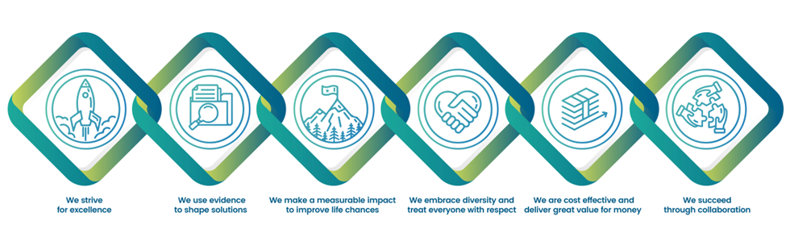
Education Development Trust is committed to safeguarding and promoting the welfare of everyone who comes into contact with us. We operate a zero-tolerance policy to sexual exploitation, abuse, and harassment (SEAH). Applicants must be willing to undergo safeguarding screening appropriate to the post, including checks with past employers and police checks. Successful candidates will be required to sign a safeguarding declaration to confirm that they will abide by the Trust’s safeguarding policies and procedures, including, but not limited to, Protection from SEAH, and the Safeguarding Code of Conduct.

Education Development Trust also participates in the Inter Agency Misconduct Disclosure Scheme and we may request information from relevant job applicants’ previous employers about any findings of sexual misconduct, including harassment, during employment, or incidents under investigation when the applicant left employment. By submitting an application, the job applicant confirms their understanding of these recruitment procedures.

