Job Description

Job Title: Human Resources and Administration Manager

Group: International

Dept/Project/Service: Leaders in Teaching (LiT)

Reports to: Programme Manager (Technical Lead) dotted reporting to SSA Head of People

Responsible for: IT Officer, Office Assistant, Liaison Assistant, Office Security

Usual office base: Addis Ababa

Grade: Will be awarded following job evaluation

Project Overview:
The Leaders in Training (LiT) Ethiopia is a national programme aiming to enhance quality of teaching and learning in secondary education. The overall objective of the programme is to improve the transition of secondary school students to either post-secondary education or training or directly into the world of work by equipping them with relevant skills, knowledge, and attitudes through enhanced implementation of the competency-based curriculum. EDT are implementing this programme in partnership with two other organisations, one of whom, the Lead Partner, will also host the Project Management Unit (PMU).

Job Purpose and Scope:
The Human Resources and Administration Manager will ensure the successful provision of the core support service functions of human resource, general administration and property to ensure that the projects key objectives can be delivered successfully. As a member of the Management Team the post holder will be responsible for shared leadership of the programme and involved in decision making across all aspects of the programme.

This Job Description may be amended when the Programme is finalised

Job objectives:

Human Resources

Resourcing and Development
- Facilitate the provision of a professional resourcing service and ensuring all appropriate contractual documentation, compliance checks and job descriptions are available to meet the resourcing needs of the project, whether through engagement of consultants or employees.
- Identifying recruitment needs, implementing processes and tracking progress of application through to Interview and offer stage in partnership with the line managers, global and regional HR
- Ensure that Safer Recruitment best practice and Education Development Trust recruitment policies and processes are followed at all times. Collect and review all required recruitment compliance documentation.
- Coordinate and attend interviews as required by line managers.
- Where required, source employment agencies for recruitment purposes ensuring value for money and service.
- Work with the Programme Coordinator and Programme Manager (Technical Lead) to ensure that Consultant scheduling and resourcing is executed in a timely and effective manner
- Develop and implement comprehensive induction and probationary monitoring processes
- Facilitate training opportunities to meet business need

General HR Administration
- Create and maintain contracts, staff files and other employee information including up to date personal records for all employees in accordance with legal requirements and Ed Dev Trust policies and procedures.
- Manage staff leave processes, by administrating and processing leave and maintaining an up-to-date data base of leave records for the region including timesheet
- Maintain the programme HR Database ensuring all staff changes, attendance and compliance records are updated accordingly.
- Prepare and ensure all contracts of employment are current and relevant. Where appropriate, prepare contract modification notices to ensure continued relevance.
- Support on employee contractual issues ensuring terms and conditions align to business policy and country law
- Ensure organization statutory compliance on HR related issues
- Administer staff benefits, i.e. medical insurance and pension as well as maintain contact with the service providers
- Manage payroll administration to ensure accuracy & compliance for timely payments Preparation and analysis of HR Management Information (MI) to support HR metrics and Key Performance Indicators (KPIs) and provide meaningful data for the project.

Employee Relations & Engagement
- Ensure that existing HR policies and procedures are regularly reviewed and updated as appropriate including sensitizing staff
- Implement agreed best practice HR policies and procedures in the programme ensuring consistency and fairness and ensuring that line managers are provided with timely and accurate advice and guidance on employee relations and current legislation.
- Provide adequate and relevant communication channels for staff thereby ensuring changes to policy, process and key information are accessible.
- Where appropriate, perform welfare duties to employees and consultants
- Where appropriate facilitate social opportunities to develop communication and networking opportunities.

Management of Administration Support Services.
- Oversee the effective provision of support services for the programme in line with cost effective guidelines.
- Ensure all Property functions adhere to legal, financial and procurement best practice
- Maintain contract renewals register for service agreements, maintenance agreements, lease agreements, hire agreements etc. Ensure all renewals are reviewed in a timely manner for ongoing effectiveness, value and need.
- Oversee the daily inspection and review of building wide facilities, logging issues and faults with the outsourced service provider or EDT contractors.
- Together with the concerned units develop and update the administration policies and procedures

Programme Leadership and Management.
- Ensure programme priorities and views of programme and administration staff are represented at the Management level.
- Ensure management team decisions are implemented
- Model the values and vision of EDT
- Support effective child safeguarding processes by complying with the global safeguarding policy, local safeguarding procedures, and the EDT Code of Conduct.
- Strengthen existing internal safeguarding processes where necessary and champion best practices in safeguarding
- Any other reasonable duty as may be assigned that is consistent with the nature of the job and its level of responsibility.

Person specification:

Knowledge:
Essential:
- Graduate level qualification in a Business Administration or Human Resources Management discipline, master’s degree would be an added advantage
- Professional Qualifications in Human Resources
- Comprehensive and sound knowledge of Ethiopian Labour Law.
- Demonstrable knowledge of HR policy/process and good practice.
- Significant understanding of effective administration, procurement, commissioning and evaluation practices with a strong sense of customer service.

Desirable:

Experience:
Essential:

- A minimum of 5 years HR and Office Administration at supervisory level.
- Experience in advising managers and employees on a range of HR issues.

Desirable:
- Prior experience of administration & HR practice within an International organisation and/or the NGO sector.
- Experience of managing teams and effective performance management.
- Experience of using IT and HR information systems

Skills:
Essential:
- Excellent verbal and written communication skills.
- Strong planning and organisational skills.
- Time management skills.
- Ability to work flexibly and cope with the ambiguity of an organisation going through change/project set up.
- Ability to maintain effective relationships.

Desirable:
- Professional membership with a certified HR body with a current practicing license where applicable
- Fluency in at least one local language from the programme regions.

Competency Band: 3
Key Competencies for the role:

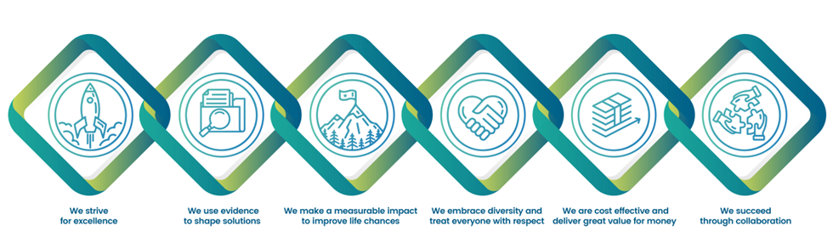
Education Development Trust is committed to safeguarding and promoting the welfare of everyone who comes into contact with us. We operate a zero-tolerance policy to sexual exploitation, abuse, and harassment (SEAH). Applicants must be willing to undergo safeguarding screening appropriate to the post, including checks with past employers and police checks. Successful candidates will be required to sign a safeguarding declaration to confirm that they will abide by the Trust’s safeguarding policies and procedures, including, but not limited to, Protection from SEAH, and the Safeguarding Code of Conduct.

Education Development Trust also participates in the Inter Agency Misconduct Disclosure Scheme and we may request information from relevant job applicants’ previous employers about any findings of sexual misconduct, including harassment, during employment, or incidents under investigation when the applicant left employment. By submitting an application, the job applicant confirms their understanding of these recruitment procedures.

